# **Project Details:**

Project name: Proposed Indoor Stadium at Illahi Bagh.

Scheme launched by: J&K Sports council Srinagar.

Contract awarded to: Mir Hilal Construction, executed by Er. Aqib Khan under the supervision of Er. Farooq Ahmed.

Site location: Illahi Bagh.

Estimated project cost: 4.32 crore.

Type of structure: Concrete and PEB structure.

Foundation type: Strip foundation.

Total height of project: 11.91 meters without truss.

Total number of columns: 51.

**About Mir Hilal Constructions:**

Registered in 2007, Mir Hilal Constructions has made a name for itself in the list of top service providers in India. The company is affiliated with all India infra builders. Mir Hilal Constructions is listed in Trade India’s list of verified companies offering wide array services especially in Srinagar, Jammu and Kashmir.

**Introduction:**

In this growing world, as civil engineering students one needs to be fully aware of the structure elements and safety parameters before and during the execution of project. This project focuses on the analysis and building estimate of Indoor Stadium for J&K sports council at Illahi Bagh Srinagar. All the structural elements are designed as per codal provisions.

The indoor stadium is a covered or a uncovered enclosed area, designed to showcase theatre, musical performance or sporting events. It is composed of large open space surrounded on most or all sides by seating for spectators. The key feature for Indoor Stadium is that the event space is the lowest point allowing maximum visibility.

As far as Indoor Stadium Illahi Bagh is concerned it is a PEB (Pre Engineered Building) structure but with the use of concrete as well.

Every structure consists of:

1. Foundation
2. Super Structure

Foundation is that part of the structure which is in direct contact with the ground to which the loads are transmitted and they are chief means of supporting a building.

The foundation generally serves the following purposes:

* Reduction of load intensity
* Even distribution of load
* Provision of level surfaces
* Safety against undermining

General Requirement of Foundation:

For a satisfactory performance, a foundation must satisfy the following three basic criteria:

* Location and depth criterion
* Shear failure criterion or bearing capacity criterion
* Settlement criterion
* Foundation used in Indoor stadium: Strip Foundation. 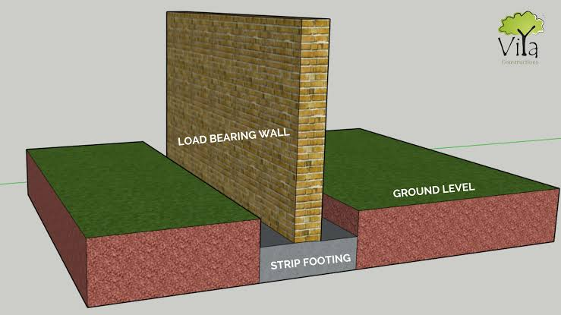

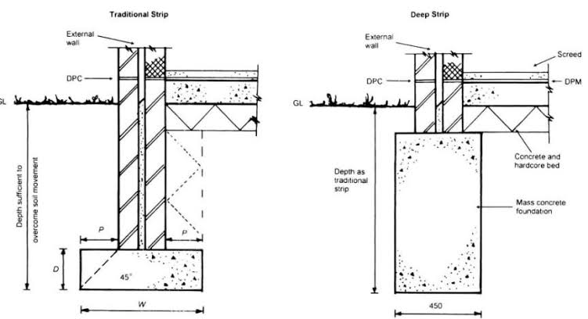

Strip foundations (or strip footings) are a type of shallow foundation that are used to provide a continuous, level (or sometimes stepped) strip to support a linear structure such as wall or closely spaced rows of columns built centrally above them.

A super structure is an upward extension of an existing structure above the base line.

Super structure in Indoor Stadium: PEB structure with the use of Reinforced Cement Concrete (RCC) as well.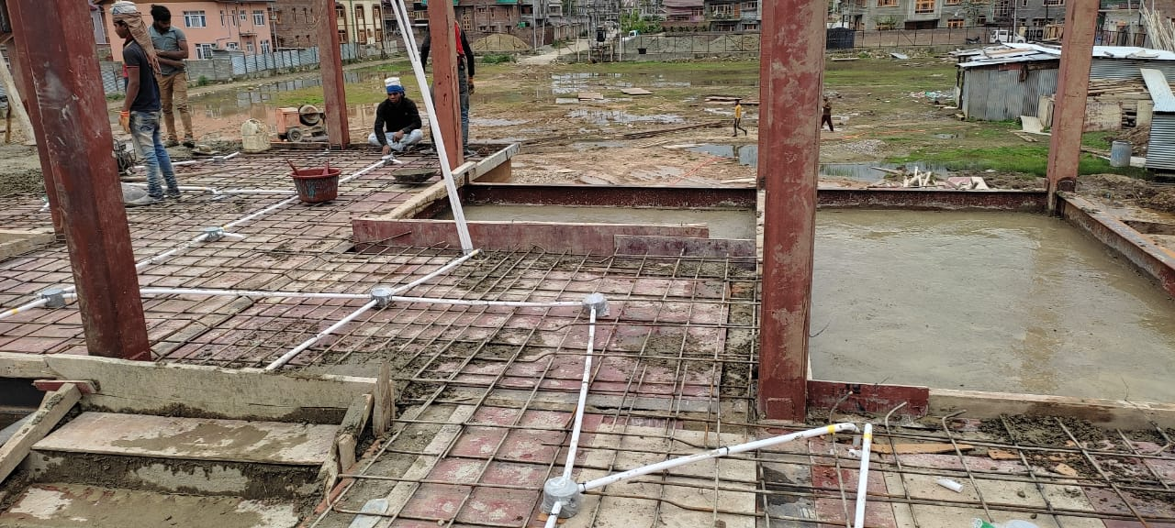

First floor slab

PEB (Pre Engineered Buildings) structures are the ones where the building components are manufactured at factory and assembled at sites. PEB’s can be adopted to suit a wide variety of structural applications, the greatest economy will be realised when utilising standard details. An efficiently designed PEB can be lighter than conventional steel building by up to 30%.

The main advantage of the PEB in KASHMIR is that it leads to reduction in construction time and lowers the cost of project. But the involvement of concrete in the structure reduces its versatility. The structure cannot be transferred from one place to another which otherwise would’ve been easier.

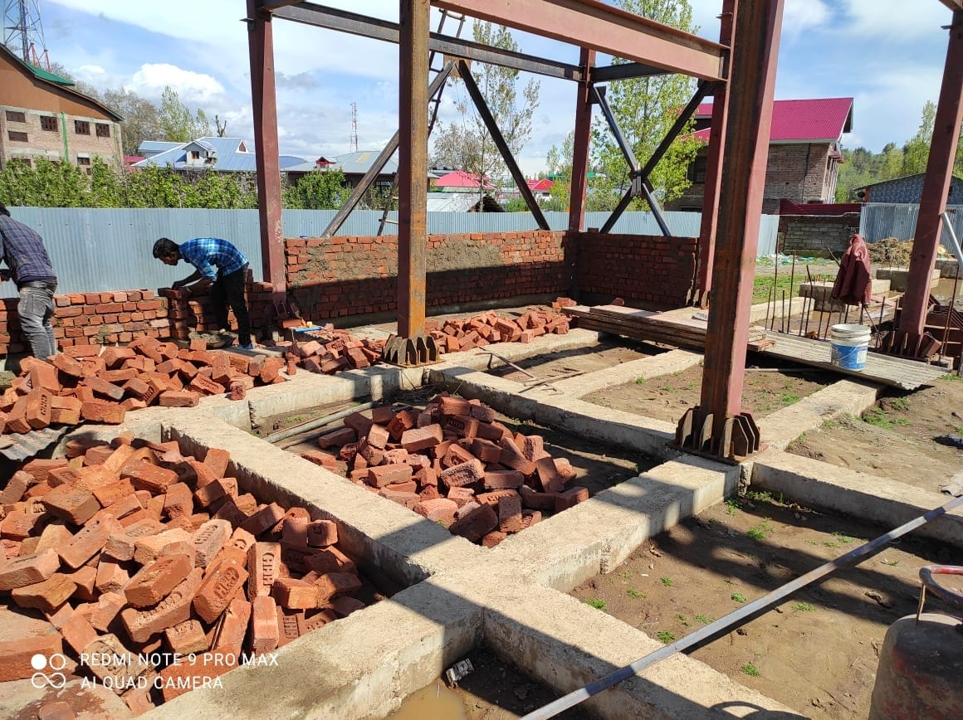

Column beam connection

# **The History of Structurally Pre-Engineered Building:**

# Understanding the history of structurally pre-engineered buildings helps to understand the history of fire. As in, things catching on fire. In the 18th century, mill towns began to spring up all over the United States, bringing with them all the trades that would support the mills’ working families.  Previously, houses and businesses had largely been spread across larger areas, which meant that fire was a remote occasion. However, new mill towns packed homes and businesses into tight areas so that a mill fire meant not only an immediate threat to the commerce of the company and destruction of its products but also a larger scale loss to the community and the mill labourers.

By the 1800s, communities were starting to develop firefighting units to help address the problem, but one major step that mill owners took in protecting their interests was using metal in the construction of their buildings. In fact, the first recorded use of metal in a building was by the Dithering Ton Flax Mill in 1796, who used cast-iron columns and framing to stave off the disastrous results of what had become infamous cotton mill fires.

So, what does this have to do with pre-engineered structures? Innovations in metallurgy, including the creation of rolled iron beams, which were used, for example, to construct the Cooper Union Building in New York, and the invention of a method to burn carbon and silicon from the pig iron to create steel, led to durable structures that could be manufactured and then transported to a site for assembly. For much of the 19th century, these one-story buildings were used for warehouses and farm structures.

Ironically, another mobile item, one that was far from the agrarian ideals of farming, changed the face of pre-engineered buildings. In 1901, due to the popularity of the Model T, consumers demanded a storage place that would protect their new cars. An American company, The Butler Brothers, stepped up to meet the need. Before 1909, the Butlers had built pre-engineered farming structures, but they quickly retooled to create the first car ports, which were arched frames over which corrugated sheets of metal were fixed.

By 1917, the phenomenon had spread beyond carports so that businesses such as the Austin Company were offering a catalogue of 10 standard pre-engineered building designs that could be shipped to a construction site within a few weeks. But it was the 1940s and World War II that made pre-engineered structures a ubiquitous part of the American landscape. The same design principles that created easily movable and just as easily assembled metal Quonset huts, insinuated their way into mainstream construction following the war.

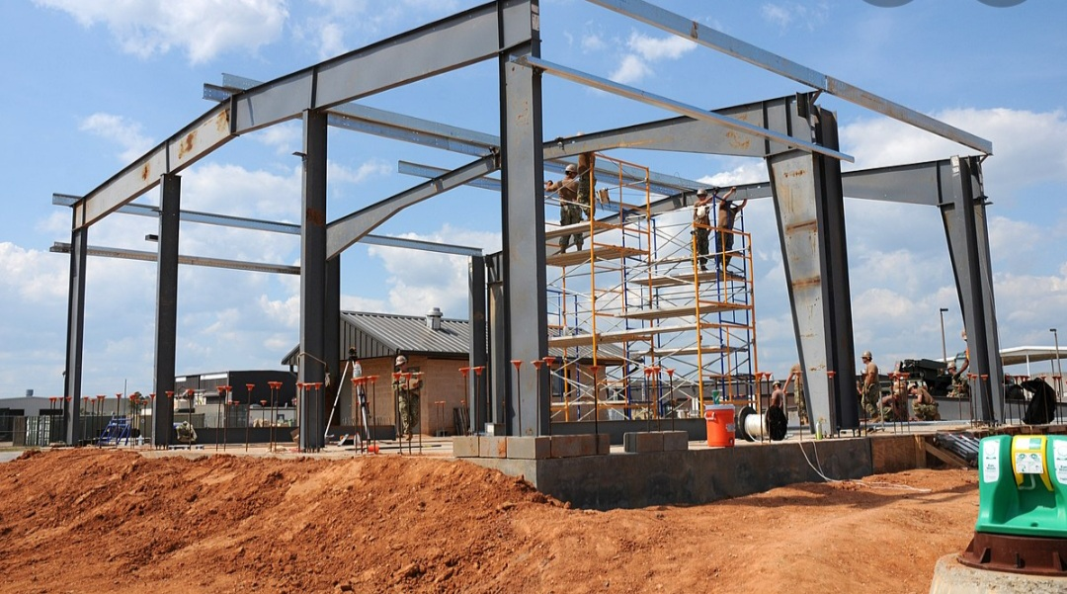 **Pre-Engineered Buildings In Modern world:**

Today, pre-engineered buildings make up more than 70% of commercial construction and almost 95% of industrial buildings. Not only has the pre-engineered market moved beyond metal, offering, for example, concrete structures manufactured off-site, but it also offers a myriad of finish options, such as stucco, stone, and synthetic sidings that transform the look of the structure.

Modern pre-engineered structures have become easy to create thanks to design software that makes the manufacturing process quicker and more accurate. And pre-engineered structures offer a number of advantages, including:

* A greater resistance to fire;
* Quicker construction time;
* Less need for a specialized labour force;
* Easy maintenance;
* Unlimited design possibilities;
* Lighter weight, which means less money spent on foundations;
* Cleaner construction sites;
* Environmentally friendly design;
* Energy efficiency

Indeed, pre-engineered structures are making a huge impact on the evaluators of innovative design. The Council on Tall Buildings recognized Broad Group for the 30-story hotel it built in China in just 15 days out of pre-assembled components. Tour Total in Berlin was also recognized for its raster facade precast concrete system, which Richard Cook of CookFox Architects noted, “shows that load-bearing precast concrete offers an alternative to the glass curtain wall for tall building construction.”

Gone are the days when pre-engineered meant flimsy, unattractive metal.  Today’s buildings are architecturally diverse, solid enough to withstand earthquakes and strong winds, energy-efficient, environment friendly, and likely to save companies money in both short- and long-term.

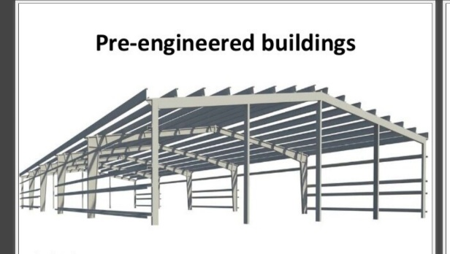

**Design codes generally used for PEBs:**

AISC: American institute of steel construction manual.

AISI: American iron and steel institute specifications.

MBMA: Metal building manufacturer’s code.

ANSI: American national standards institute specifications.

ASCE: American society of civil engineers.

UBC: Uniform building code.

**Codes used in India as per IS:**

YIS 800: For design of structural steel.

YIS 800-2007: For design of structural steel by LSM.

MIS 801: For design of cold formed section.

MIS 875: For calculation of loads.

**Main framing:**

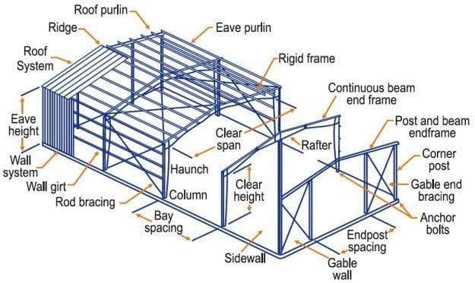

Main framing of PEB

Main frames include steel rigid frames of the building. The PEB steel rigid frames include tapered columns and tapered rafters. These tapered sections are fabricated using the state of art technology while the flanges are welded. The frame is then erected by bolting the splice plate of connecting section together.

Columns:

Columns are vertical compression members used to transfer the loads of the structure. Columns are most important parts of structure. The failure of any part of structure may not cause so serious damage as that caused by failure of a column.

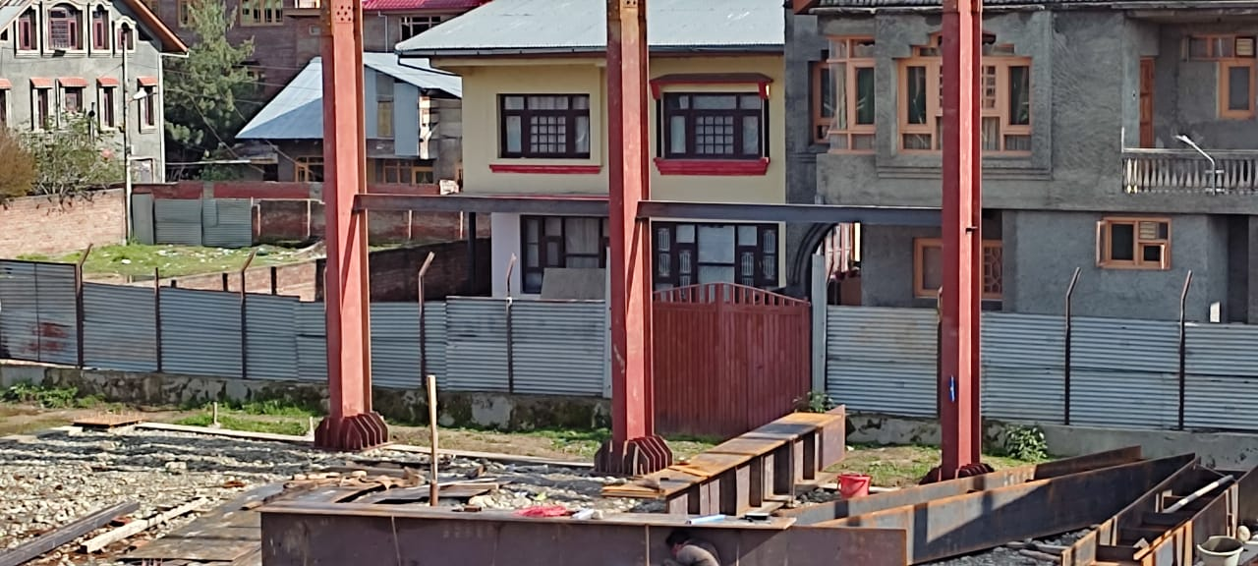

Columns

COLUMNS USED AT THE SITE:

|  |  |  |  |  |
| --- | --- | --- | --- | --- |
| S.NO. | COLUMN DESIGNATION | LENGTH (in meters) | SECTION TYPE | UNIT WEIGHT(Kg/m) |
| 1. | COLUMN C1(HALL SIDE) | 11.91m | ISMB 600 | 123 Kg/m |
|  | COLUMN C1(FRONT SIDE) | 9.069m | ISMB 600 | 123 Kg/m |
| 2. | COLUMN C2 | 1.72m | ISMB 400 | 61.5 Kg/m |
| 3. | COLUMN C3 | 11.110m | 4 ISA- 150×150×10 | 4×22.9 Kg/m |
| 4. | COLUMN C4 | 9.069m | SHS 180×180×8 | 42.7 Kg/m |
|  |  | 11.91m | SHS 180×180×8 | 42.7 Kg/m |
|  |  | 6.097m | SHS 180×180×8 | 42.7 Kg/m |

Joint plates:

Joint plates are steel plates often used to assure continuity for structural members along their length. The joint plates can be bolded or welded to the main members.

Size of joint plates used at the site:

For main beam:

* Web joint plates: 560×430×10 mm
* Flange joint plates on outside: 860×200×16 mm
* Flange joint plates on inside: 830×100×16 mm
* For columns: 1000×150×10mm

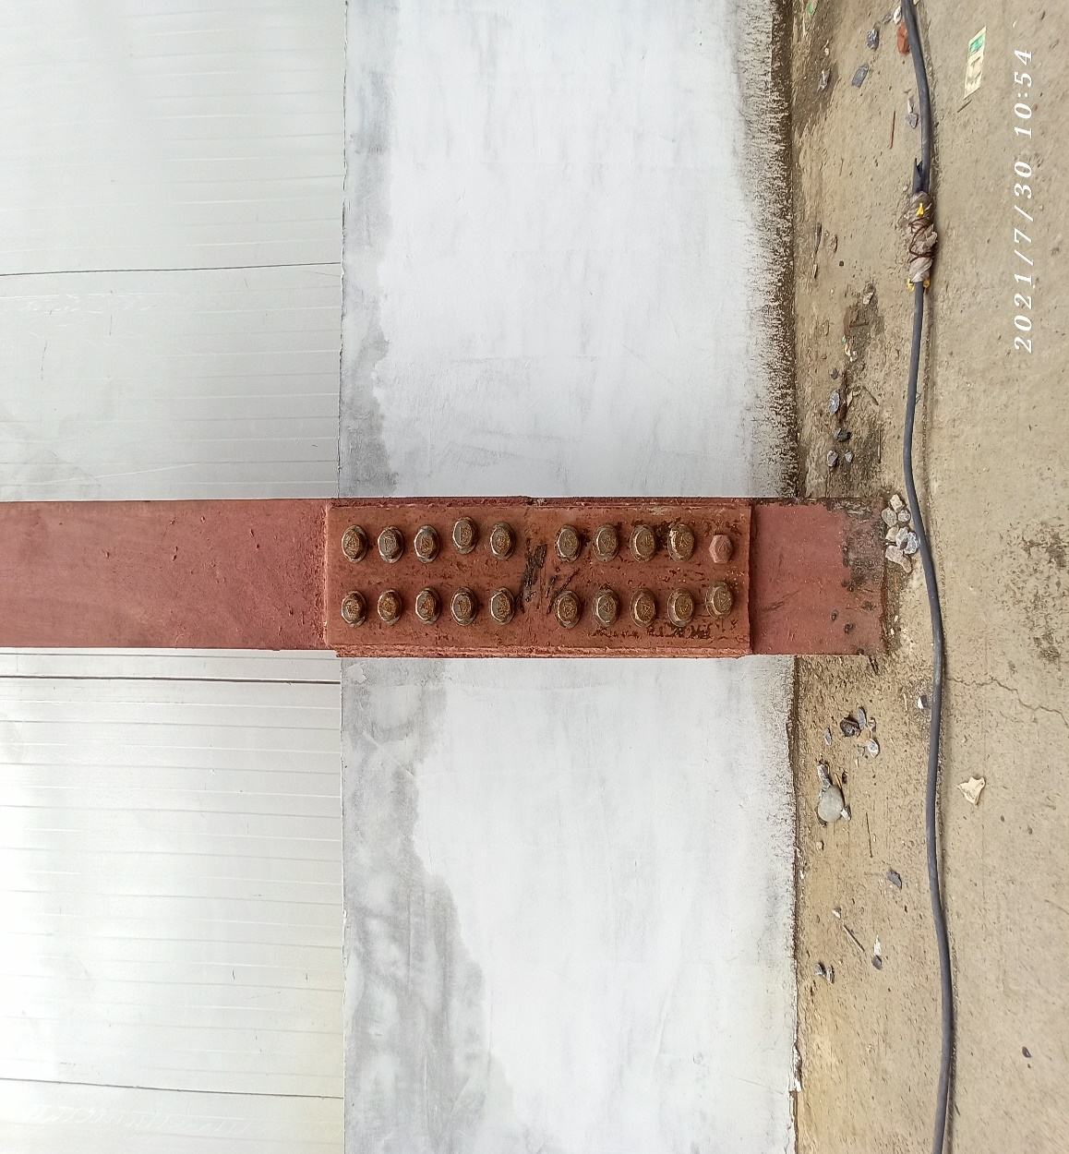

Joint plates

Base plates:

Base plates usually are attached to the column during the fabrication of the structural steel and delivered as one piece. A base plate is provided to distribute area of concrete foundation. The base plate is usually set using levelling screws attached to the sides of the plate and then grouted.

Size of base plates used at the site:

BP1A:800×800×20 mm

BP2A:800×800×20 mm

BP1: 800×800×20 mm

BP2:600×600×20 mm

BP3:600×600×20 mm

BP4:450×450×16 mm

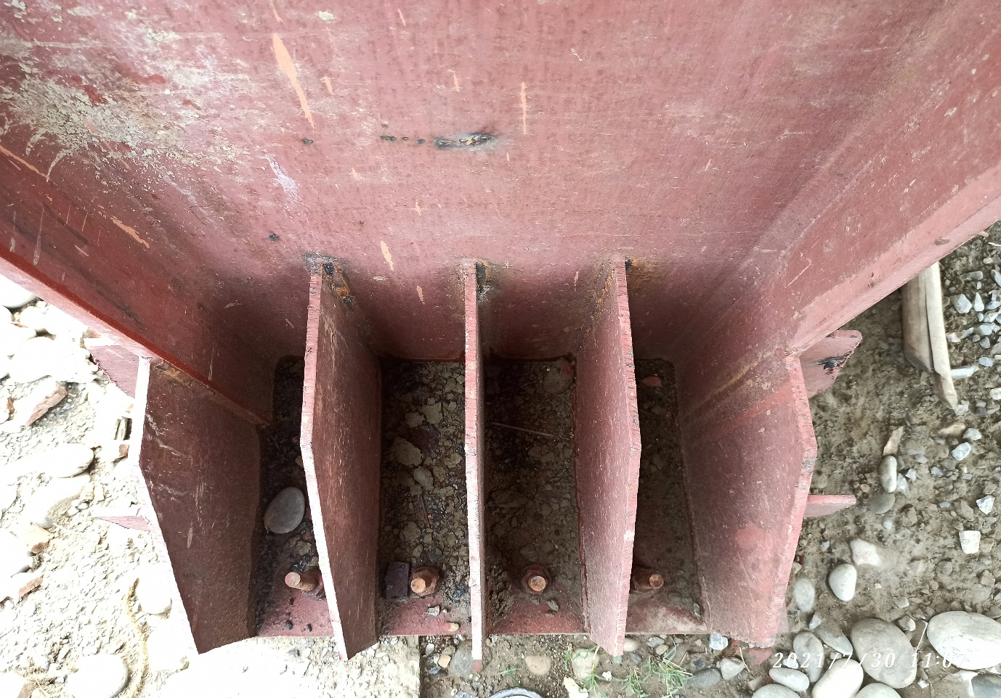

Base plates

Batten plates:

Battens are steel plates used to connect the main components of compression members. Battens should be placed opposite to each other on the two parallel faces of compression members.

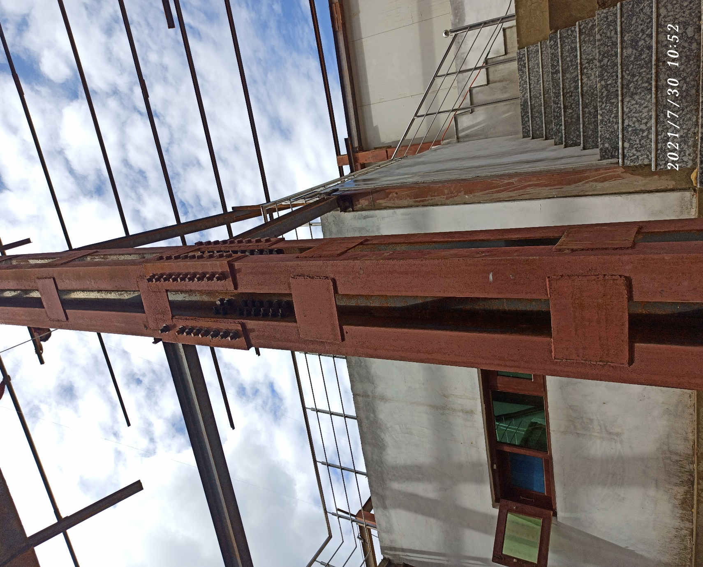

Batten plates

Stiffeners:

Stiffeners are secondary steel plates or sections which are attached to beam webs or flanges to stiffen them against or out of plane deformations.

Size of stiffeners used at the site:

In main beam: 750×150×12 mm

In columns:750×250×10 mm 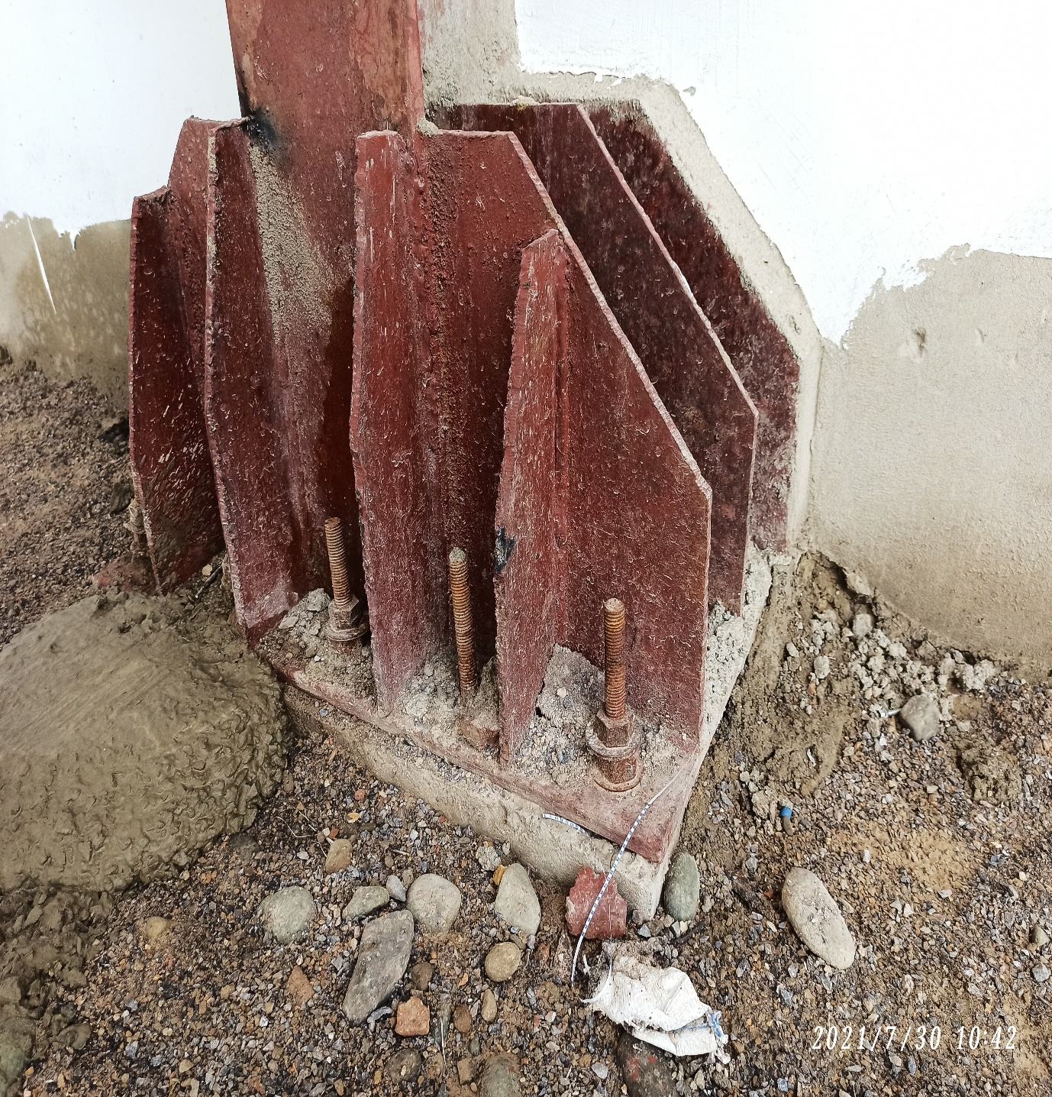

stiffeners

Bracings:

To manage seismic and wind loads in a pre-engineered building, different forms of bracings are used. The most common is cross bracing. Using solid rods, angles, or cables, each brace is fastened to the top and bottom of the main frame making an ‘X’ between the two rigid frames. Depending on the size and height of the building, and on the wind and seismic loads, the number of braced bays required will vary but at a minimum one bay per side is required.

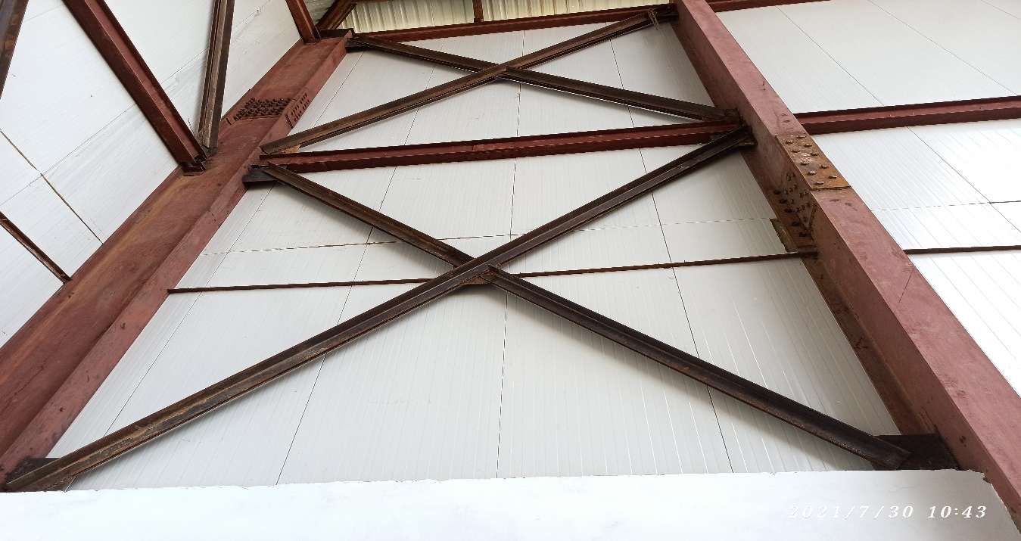

Bracings

Truss:

A truss is a structure that consists of members organized into connected triangles so that the overall assembly behaves as a single object. Trusses are most commonly used in bridges, roofs and towers. A truss is a web of triangles joined together to enable the even distribution of weight and the handling of changing tension and compression without bending and shear. All the joints are pin joints. All the members are straight. Generally, the overall efficiency of a truss is optimized by using less material in the chords and more in the bracing elements. 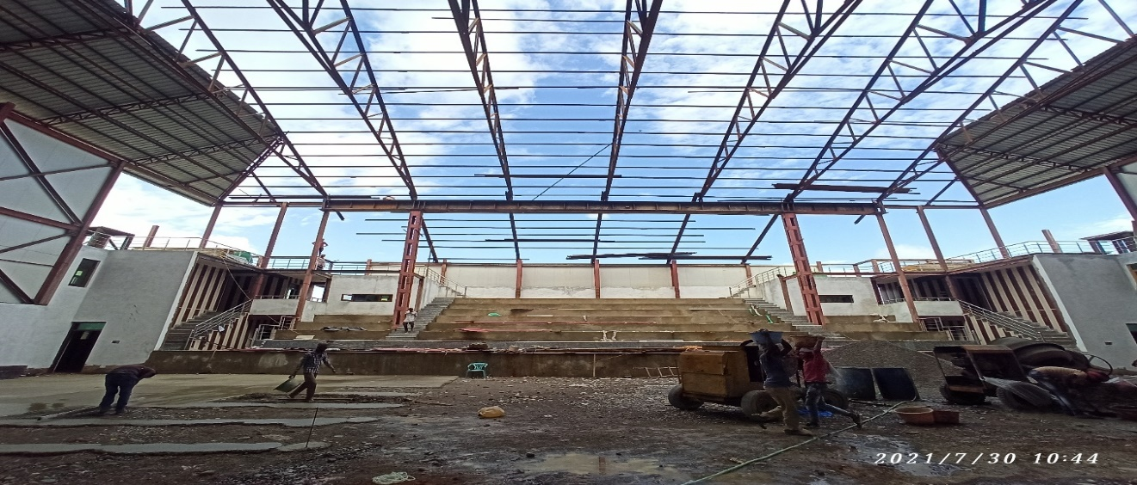

Truss

Anchor bolts:

Anchor bolts are used to connect structural and non-structural elements to concrete. The connection can be made by a variety of different components. The following anchor bolt types represent commonly used fixing to the concrete foundation: hooked bars for light anchoring, cast-in-place headed anchors and anchors bonded to drilled holes. When it is necessary to transfer a big force, more expensive anchoring systems are used.

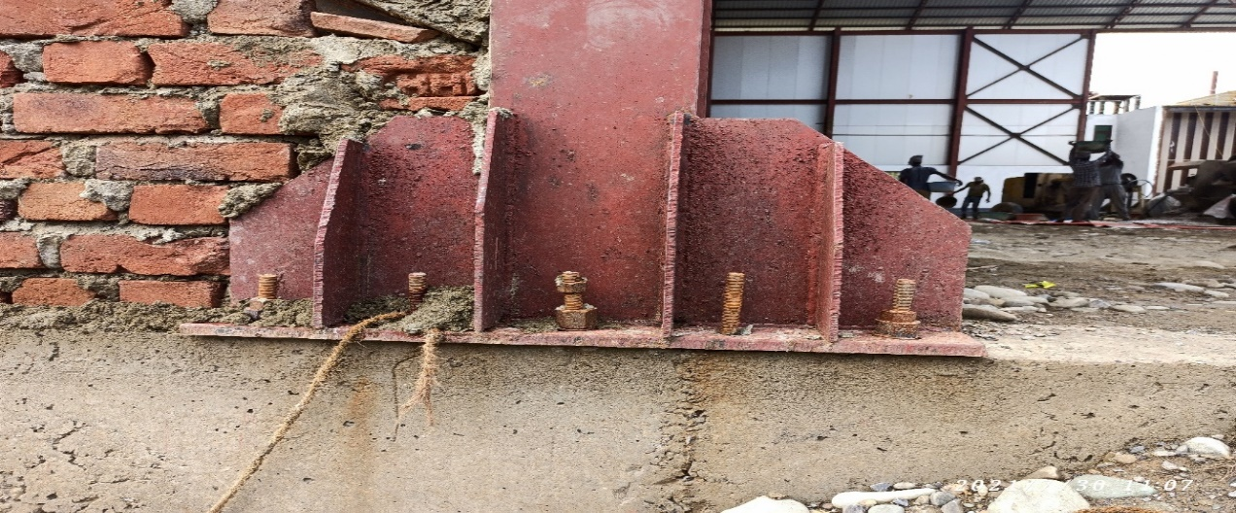

Anchor bolts

PUF panel:

Construction trend has changed these days. Nowadays PUF panels are used in both walls and roofing. PUF panels are an acronym of polyurethane foam which is a layer of material sandwiched between two GI metal sheets. The foaming material ensures proper insulation from heat as well as from cold, maintaining the room temperature inside. These insulated sandwich panels can be integrated using joists and studs. These structures have a huge demand in the market owing to their durability and high strength.

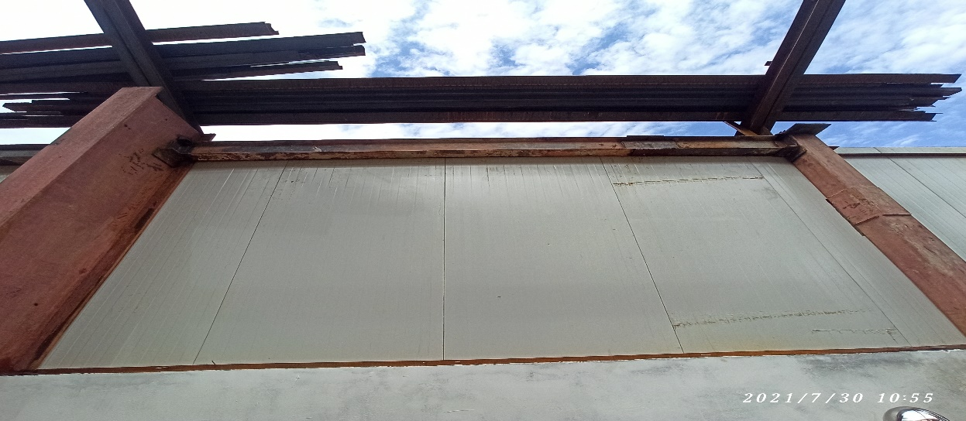

PUF wall panel

Cleats:

Cleat is ideal for making joints, connections with channel sections or angle sections. Often found connecting wall girts to columns, roof battens or roof purlins to rafters and the like. The holes punched in the assorted size GPB brackets are punched to match standard purlin punching in the ends of purlins of a matching size.

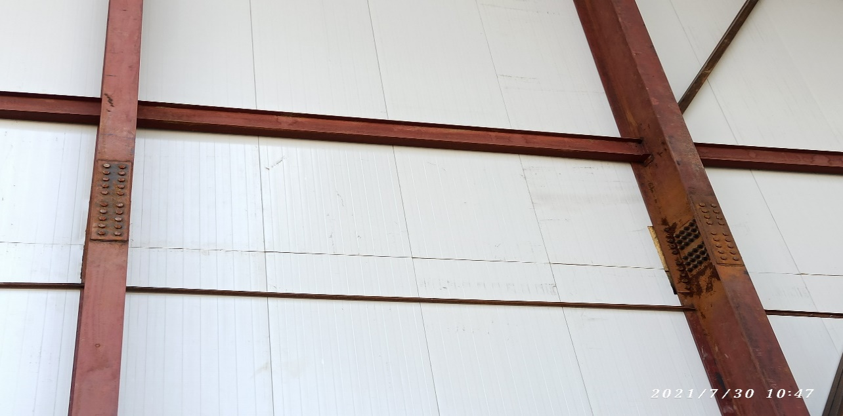

Cleats